Applying OSG Payments

OSG Payments are more difficult than normal payments because they can have 30 or more customer numbers. This will require you to partially apply while also making sure that everything remains balanced. Also, the invoices listed for these payments usually calculate discounts with freight/tax included in the calculation. Sometimes there are details about why an invoice is being short/over paid (usually it will be short paid).

Contents:
Part A: Setting up Invoice Match and Problem Invoices
This section will prepare the remittance for Invoice Match and separate the problem invoices. Problem invoices are those that weren’t found or that have a short/over pay not equal to zero.
Part B: Running the Macro and Setting up Formulas
Part C: Analysis of Problem Invoices
[C1]: Invoices Not Found
[C2]: Short/Over pay Invoices
Part D: Posting the Easy Invoices (short/over pays of 0)
Part A: Setting up Invoice Match and Problem Invoices
(Make sure you open the OSG file in a new Excel so you don’t have the text to column issue)

- Open the OSG back up in a new excel.
- Select Columns C, D, and S: (invoice number), (amount), (shortpaycomment), and copy (ctrl+c)
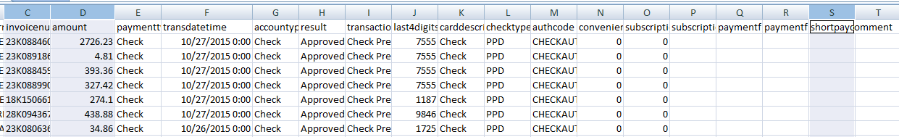
- Paste them to a new tab, then select column C and cut (ctr+x), then right click column A and click “Insert Cut Cells”

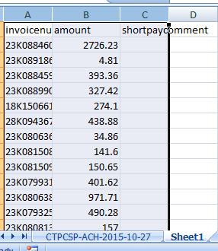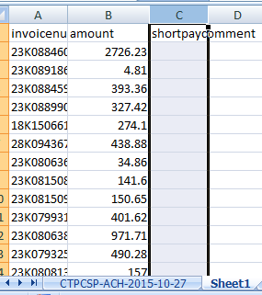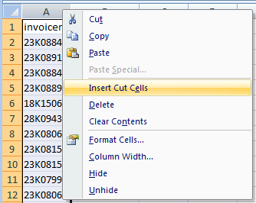

- Select and copy all 3 columns (except the first row) into the Access Invoice Match Table and run the Invoice Match Query.
- Copy over the Invoice Match results into a new tab in excel. Hit the Wrap Text (maybe twice) to fix the row heights:

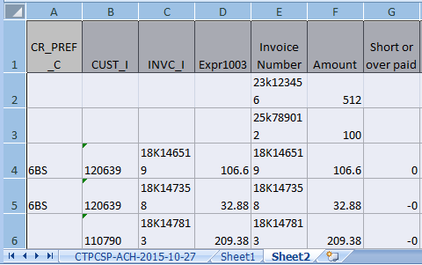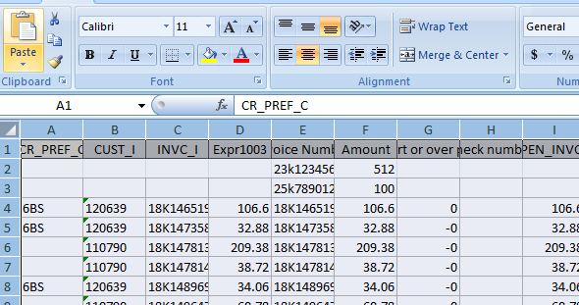

- (If you don’t have any invoices not found, skip this step!) Cut paste any rows of invoices that weren’t found into their own tab. Please make sure to delete the blank rows after the invoices are cut over.
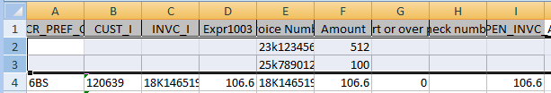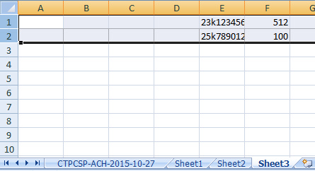
- Select all the columns and click the Data Tab, Filter button. Sort by column G Smallest to Largest

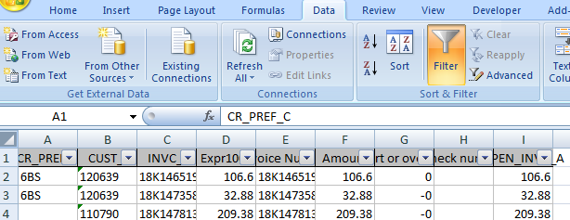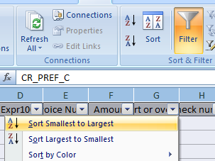

- Cut and paste all the rows that have a short or over pay of zero to another tab starting on row 2 of that new tab. These will be the easy ones to apply.
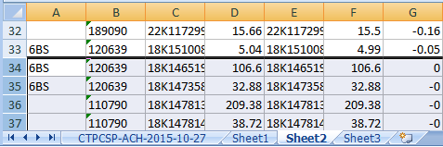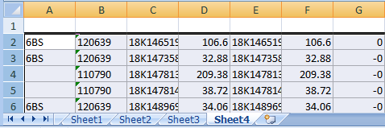

- Make sure you delete the blank rows you just moved over. Otherwise, you will sometimes be stuck not balancing or the macro not working because there was an invoice at the very bottom.

Part A Complete
Part B: Running the Macro and Setting up Formulas

